Prestashop Placet Group Gateway Module
Recommended requirements: php: >=7.2, prestashop: >=1.6
Install:
In admin panel:
Moduls -> Module Manager -> Upload a module
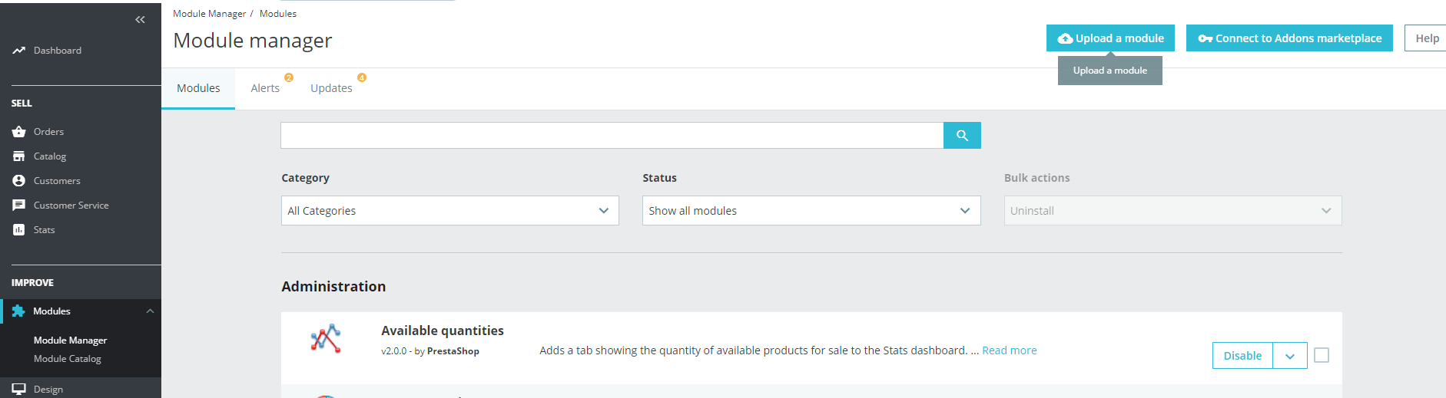
Then upload archive with module
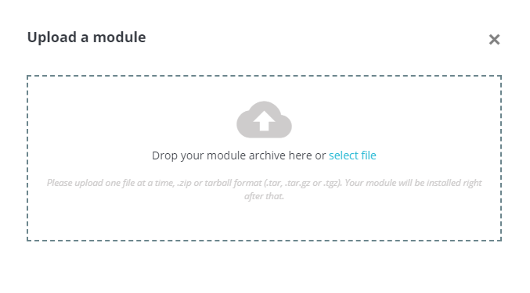

Settings:
Payment -> Payments method -> Placet Group -> Configure
Development (test) server URL: https://web-partner.laen.ee/ALIAS/requestToken
Production server URL: https://partner.laen.ee/ALIAS/requestToken
where ALIAS name ask from Placet Group IT Team

