Prestashop plugin
Tarkpay offers a Payment plugin for Prestashop. This plugin is for Prestashop 1.7 and for Prestashop 1.6 is coming. Our payment plugin is developed only for EUR currency and allowed e-shop countries are EE, LV and LT.
You can download the plugin: here
1.1 The first step is to login into admin panel and navigate to Modules->Module Manager.
1.2 Choose "Upload a module" and upload tarkpay.zip
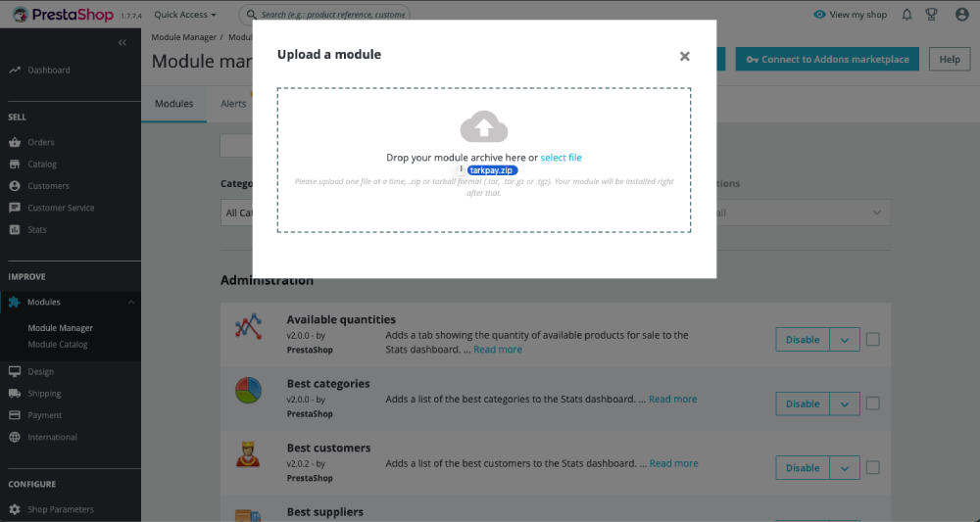
1.3 If upload was successful then click "Configure". If theres not such button you must search for "tarkpay" in Module Manager.
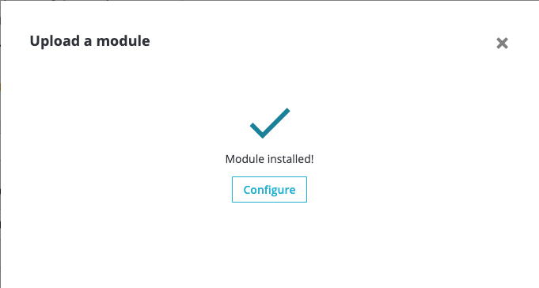
2. Fill inputs with correct data and hit "Save".
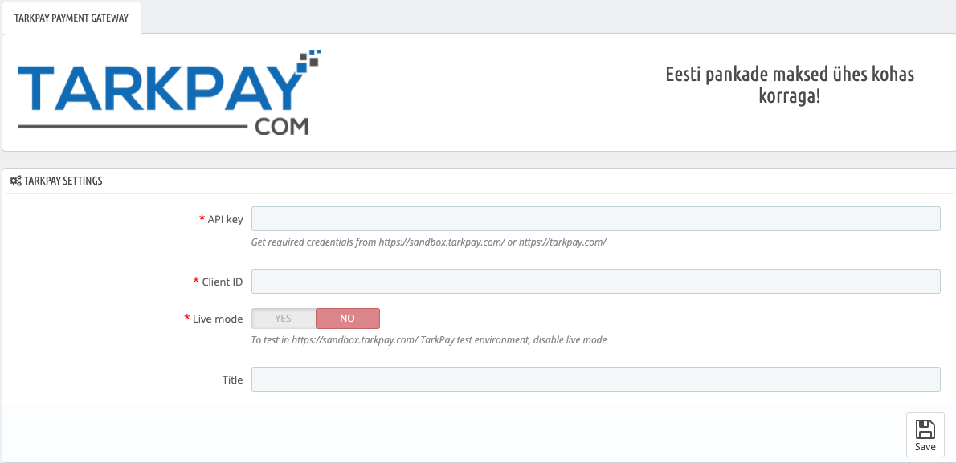
3. Go to checkout and find out if everything works fine. The result should look similar to next picture.
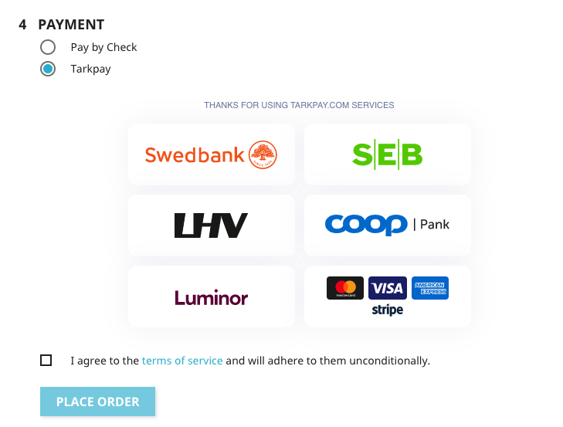
If you want to test the solution with Sandbox mode, the best way is to use LHV or Swedbank as a payment option, as it does not require you to register a special account.
In LHV, choose the option "Sandbox" and click on Enter.
In Swedbank, username: tarkpay and password: tarkpay.

