WooCommerce Placet Group Gateway Plugin
Recommended requirements: php: >=7.2, woocommerce: 5.2.2
Install:
In admin panel:
Plugins -> Add New
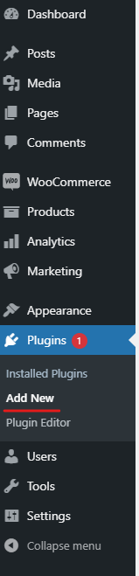

Upload plugin
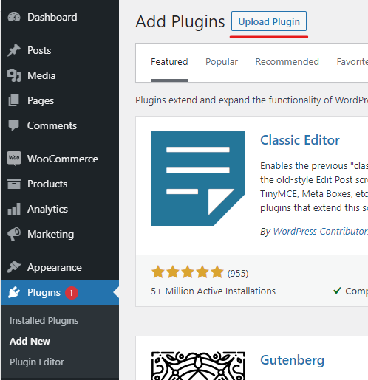
Chose zip archive with plugin and install
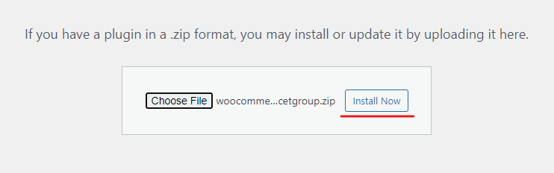

Settings:
WooCommerce -> Settings -> Payments -> Manage (Placet Group Gateway)
Title: title of gateway at checkout page
Description: description of gateway at checkout page
Url: merchant url provided by Placet Group in format:
DEV (sandbox) server - https://web-partner.laen.ee/<shop title>/requestToken
PRODUCTION (LIVE) server - https://partner.laen.ee/<shop title>/requestToken
